**EXP NO 3: CREATE A SIMPLE CLOUD SOFTWARE APPLICATION FOR PROPERTY BUYING & RENTAL PROCESS (IN CHENNAI CITY) USING ANY CLOUD SERVICE PROVIDER TO DEMONSTRATE SAAS.**

**DATE:**

**AIM:**

To Create a simple cloud software application for Property Buying & Rental process (In Chennai city) using any Cloud Service Provider to demonstrate SaaS.

**PROCEDURE:**

**step1:** Go to zoho.com.

**step 2:** Log into the zoho.com.   
**step 3:** Select one application step.

**step4:** Enter application name as property buying & rental.  
 **step 5:** Created new application as property buying & rental.

**step 6:** Select one form

**step 7:** The software has been created.  
**IMPLEMENTATION:**

**STEP1: GOTO ZOHO.COM**

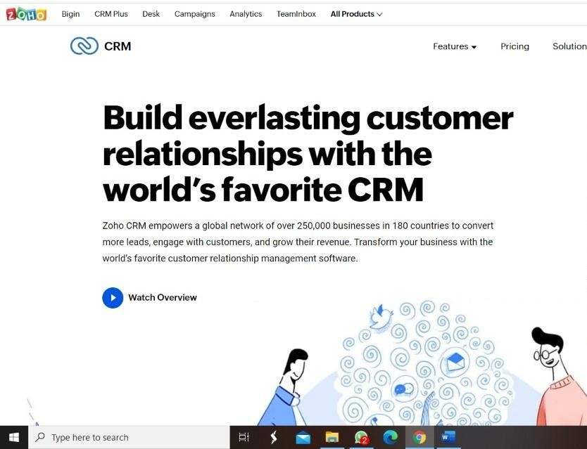

**STEP 2: LOGINTOTHE ZOHO.COM**



**STEP 3: SELECT ONE APPLICATION**

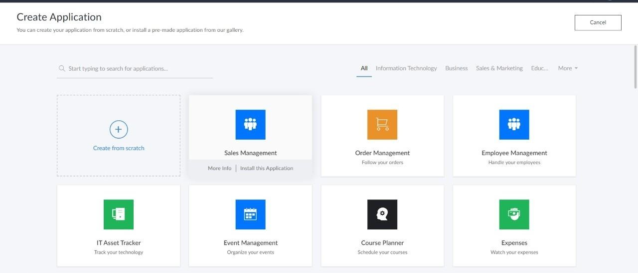

**STEP 4: ENTER APPLICATION NAME**

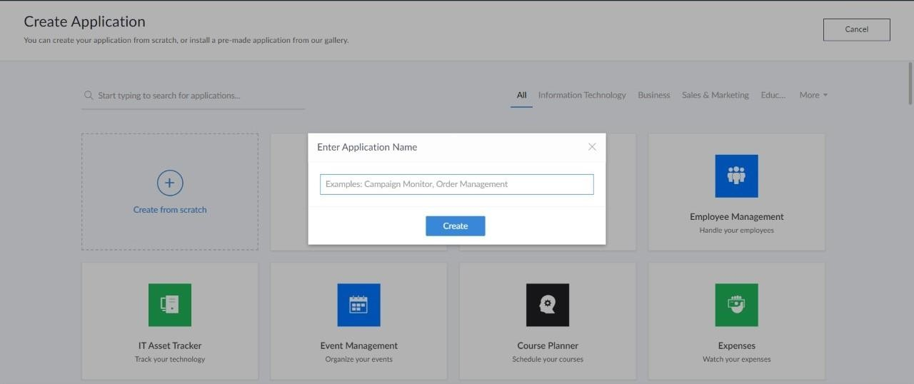

**STEP 5: CREATED NEW APPLICATION**

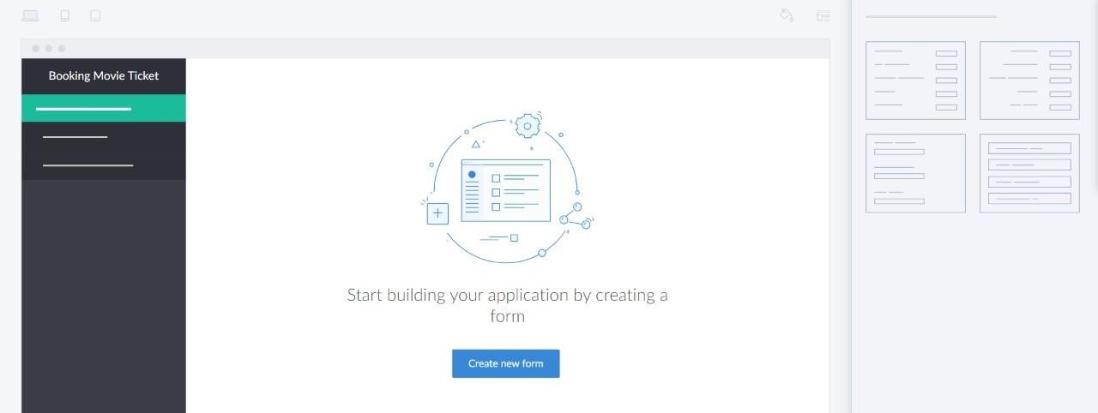

**STEP 6: SELECT ONE FORM**

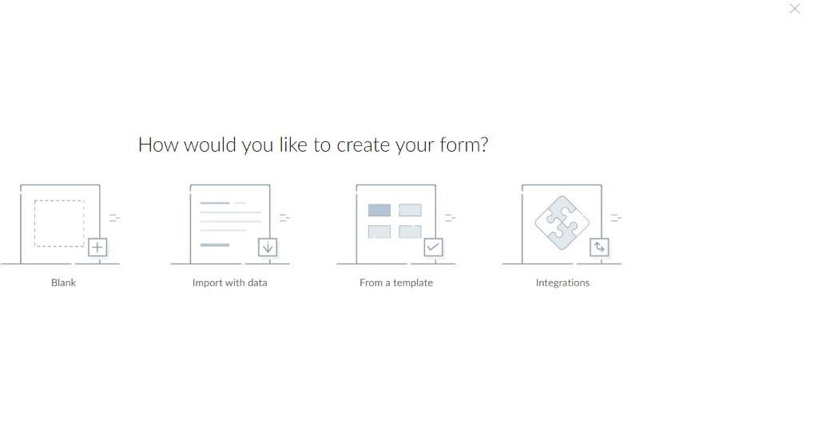

**STEP 7: THE SOFTWARE HASE BEEN CREATED.**

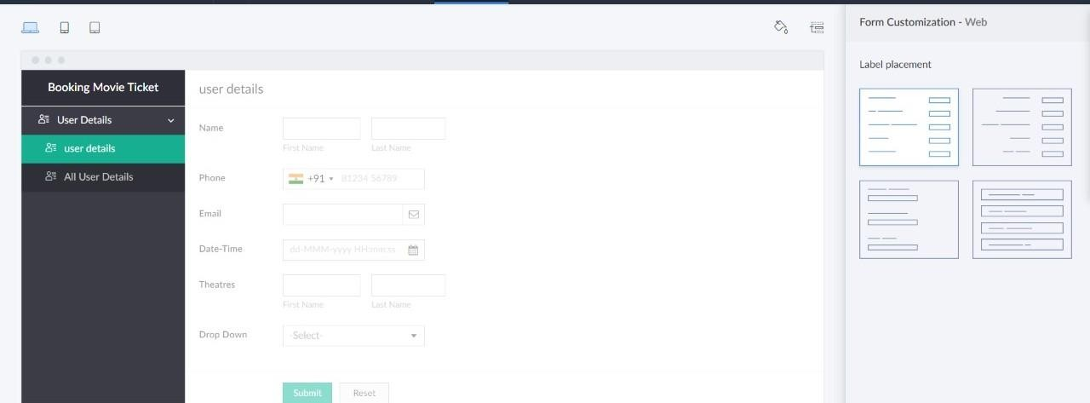

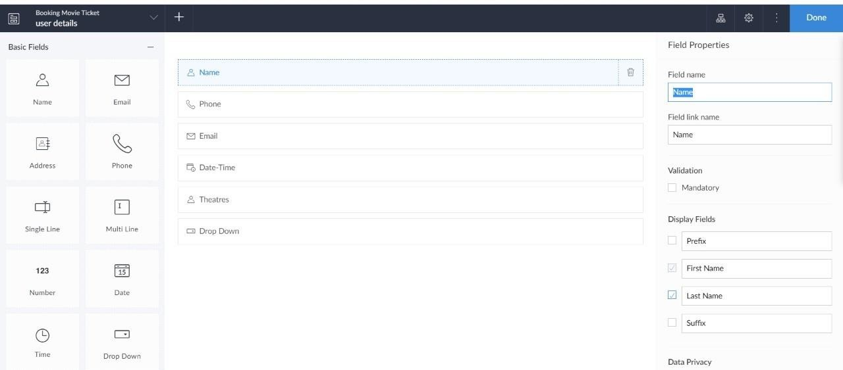

Sample output:

User Registration:

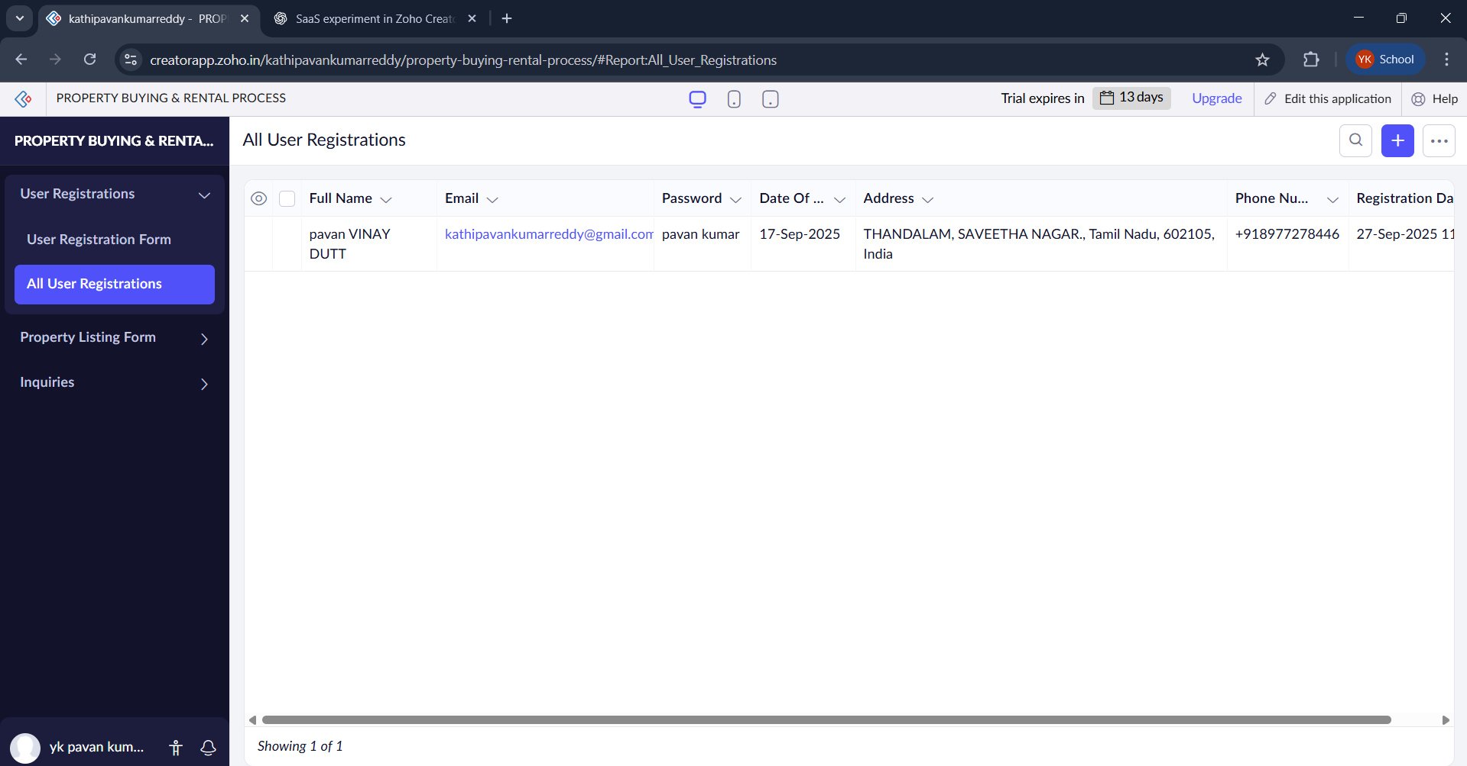

Property listing Form:

Property listing Form:

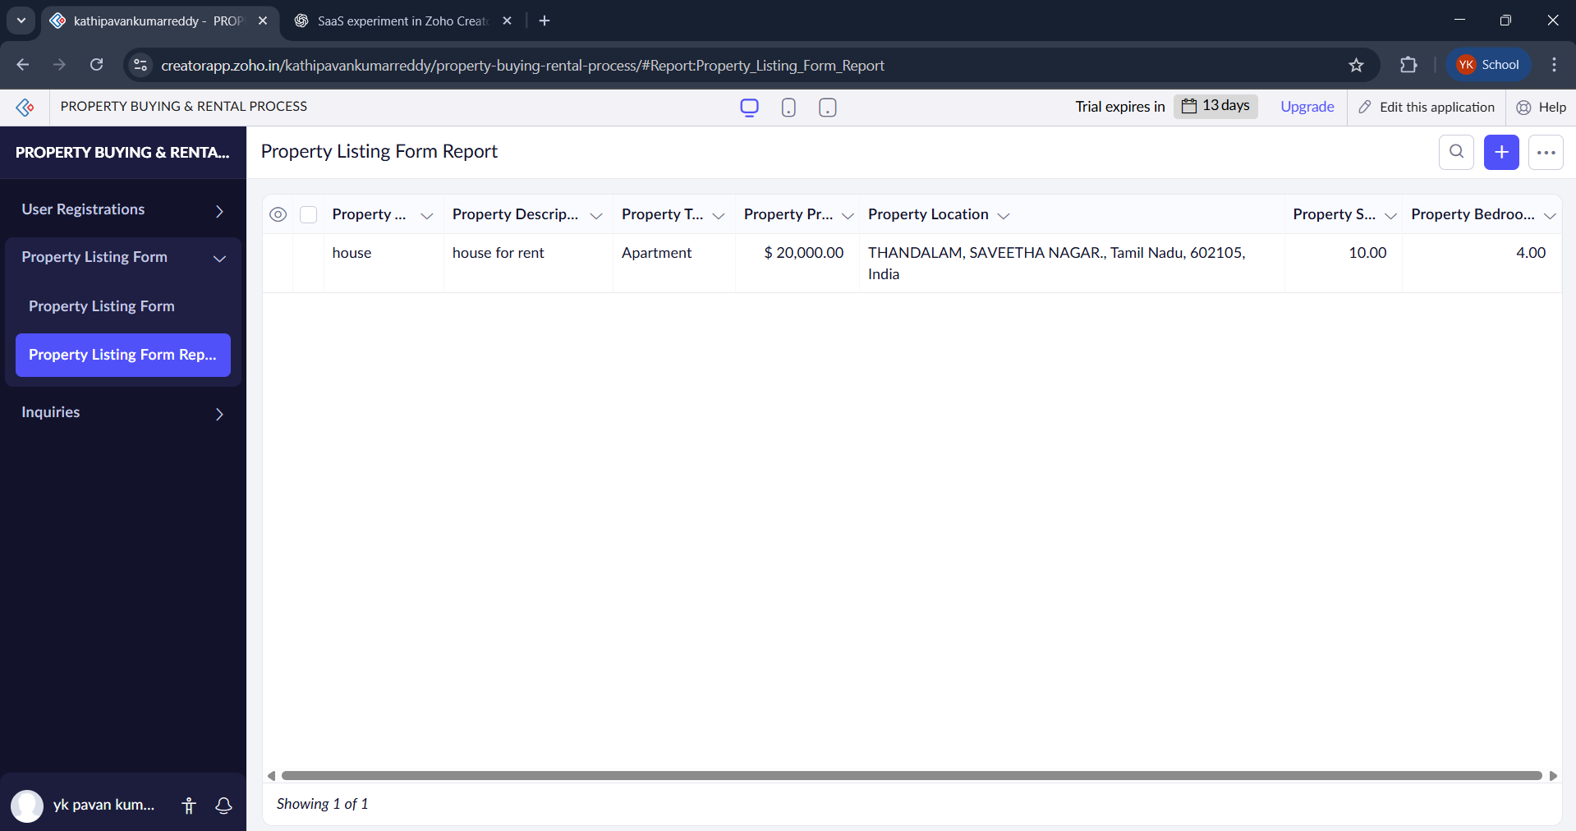

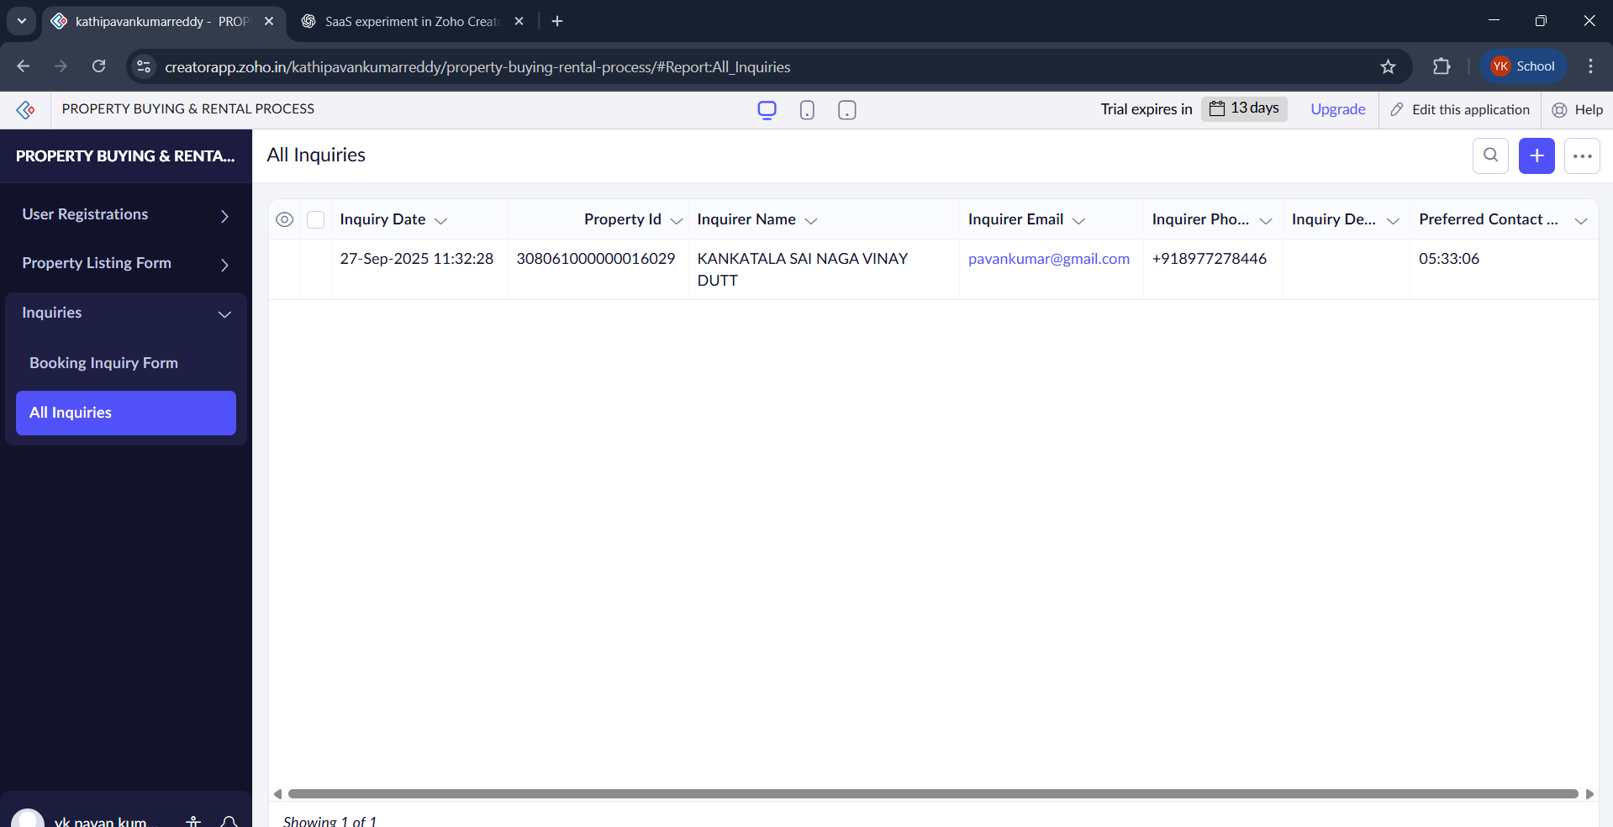Booking Inquiry form: